**DOCKERS INSTALLATION**

Click on the following link to download the executable file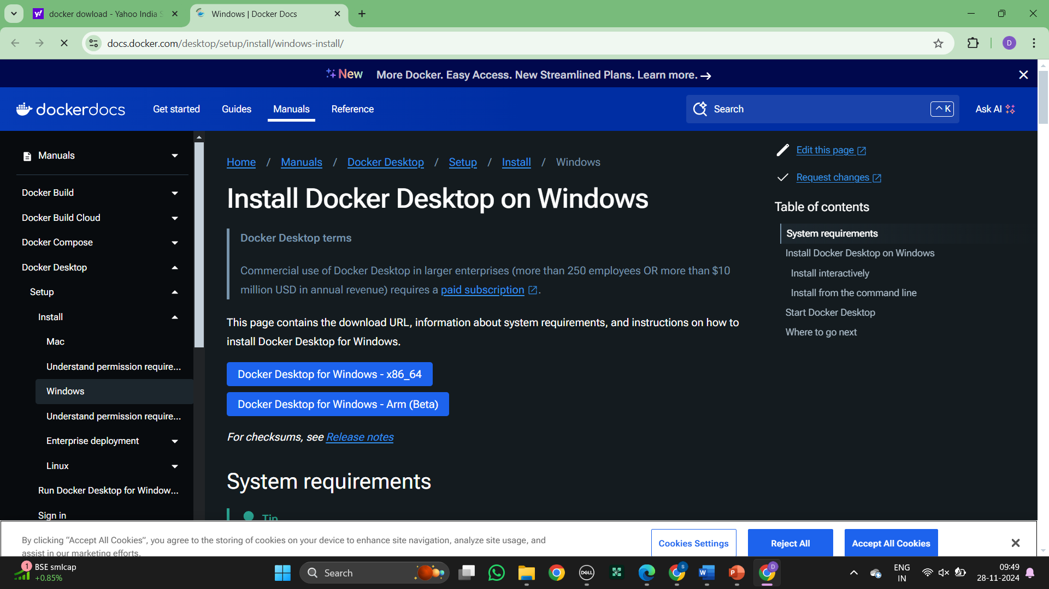

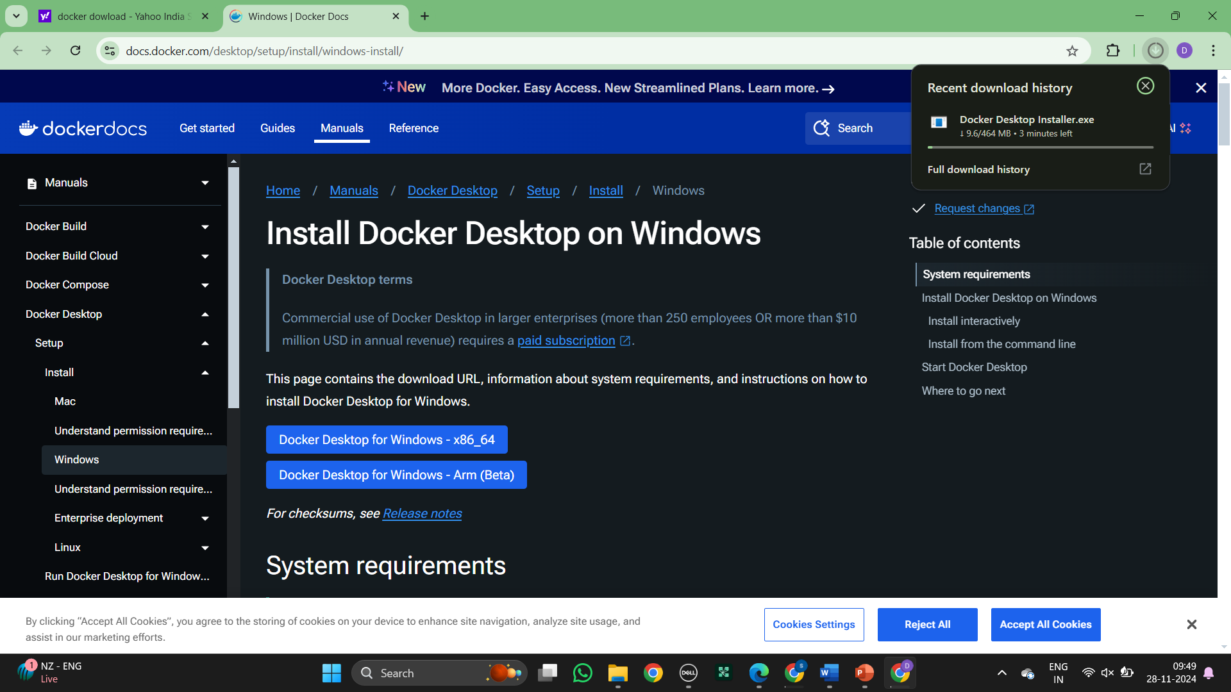

Make sure Virtualization is enabled in the system, we can check it in task manager as shown

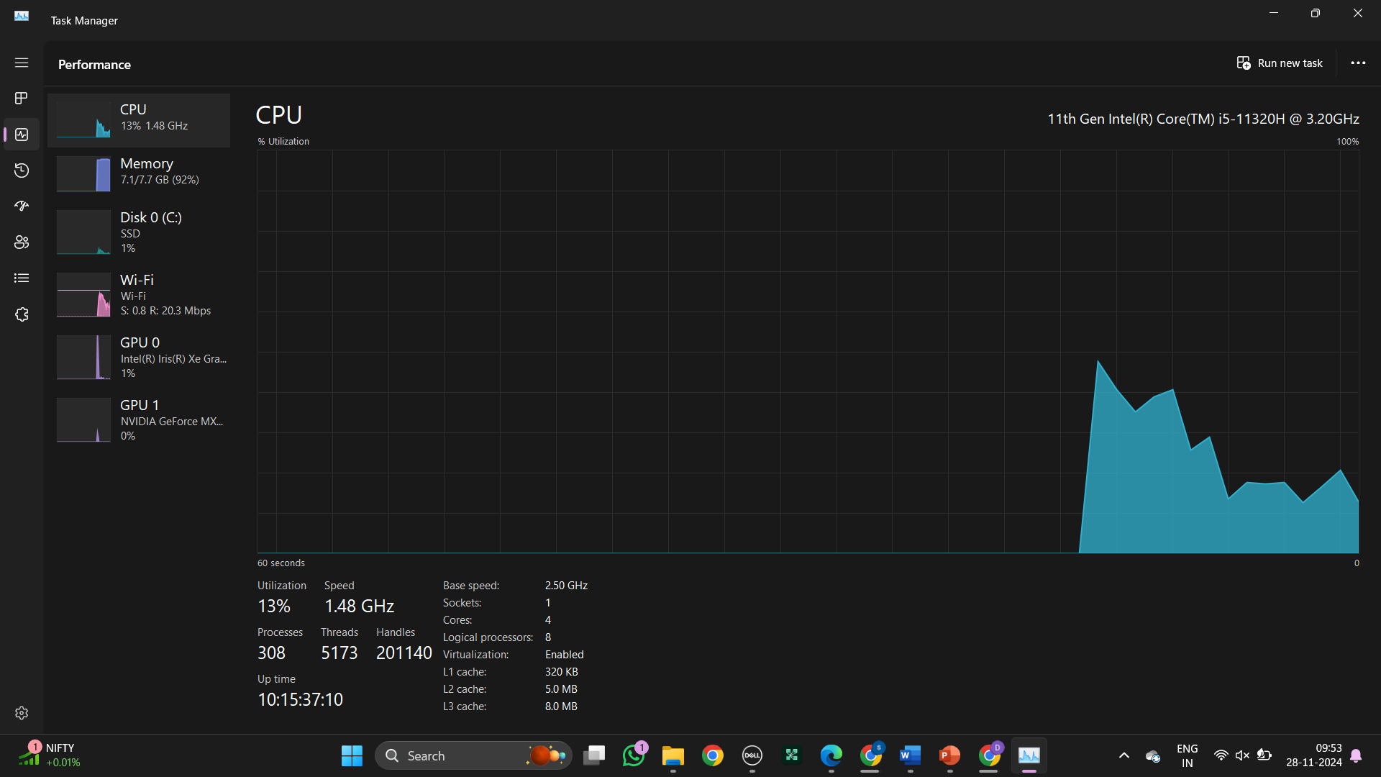

Make sure to check the Hyper-V, Virtual Machine Platform, Windows Hypervisor Platform and Windows subsystem for Linux checkboxes and click ok

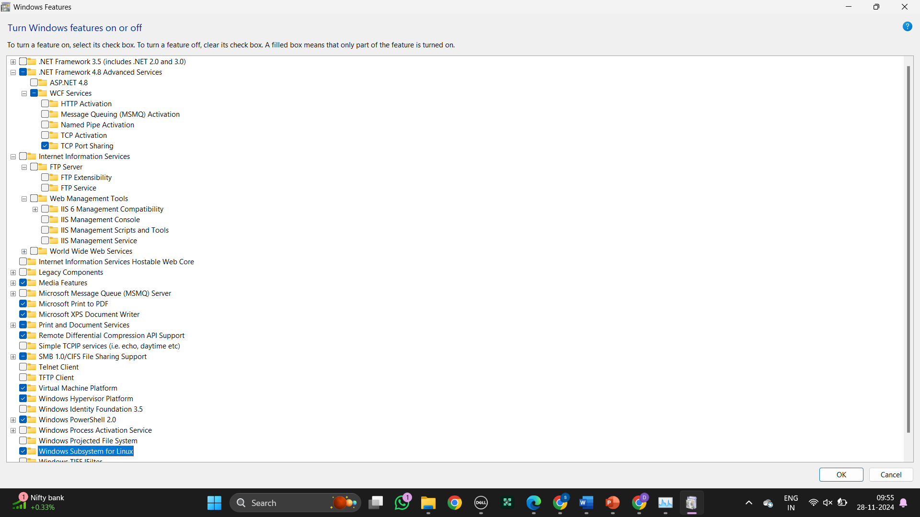

The download has started

Double click the executable file and click ok as shown, make sure the following check boxes are selected

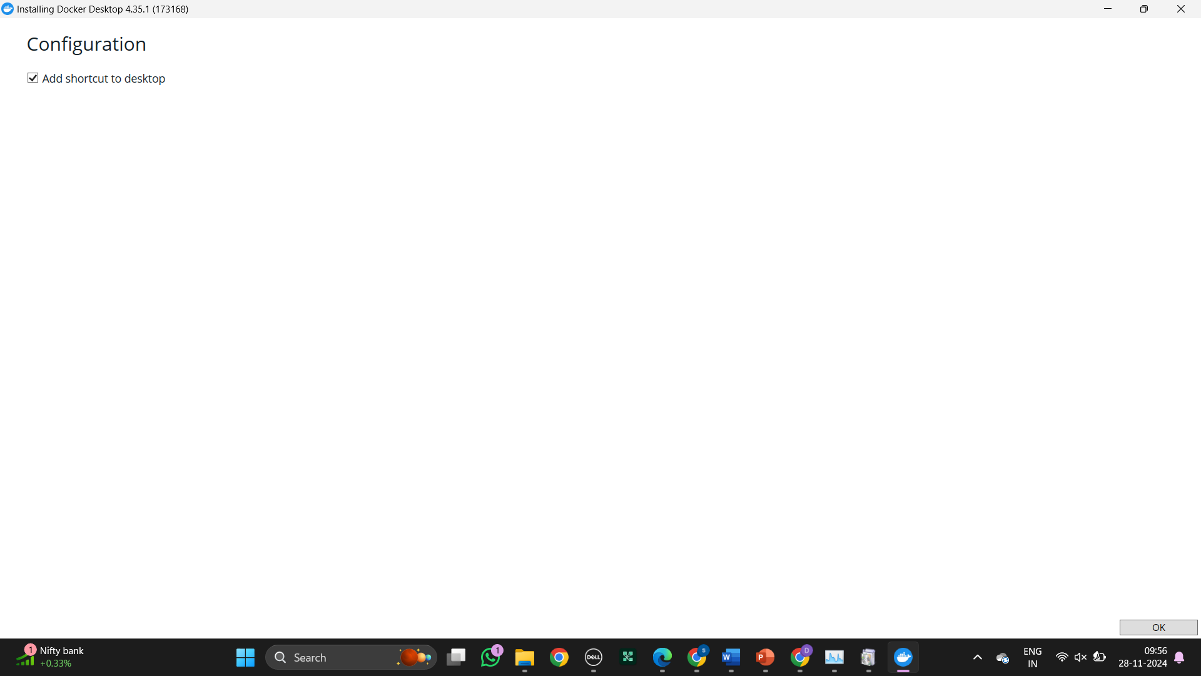

The download has started

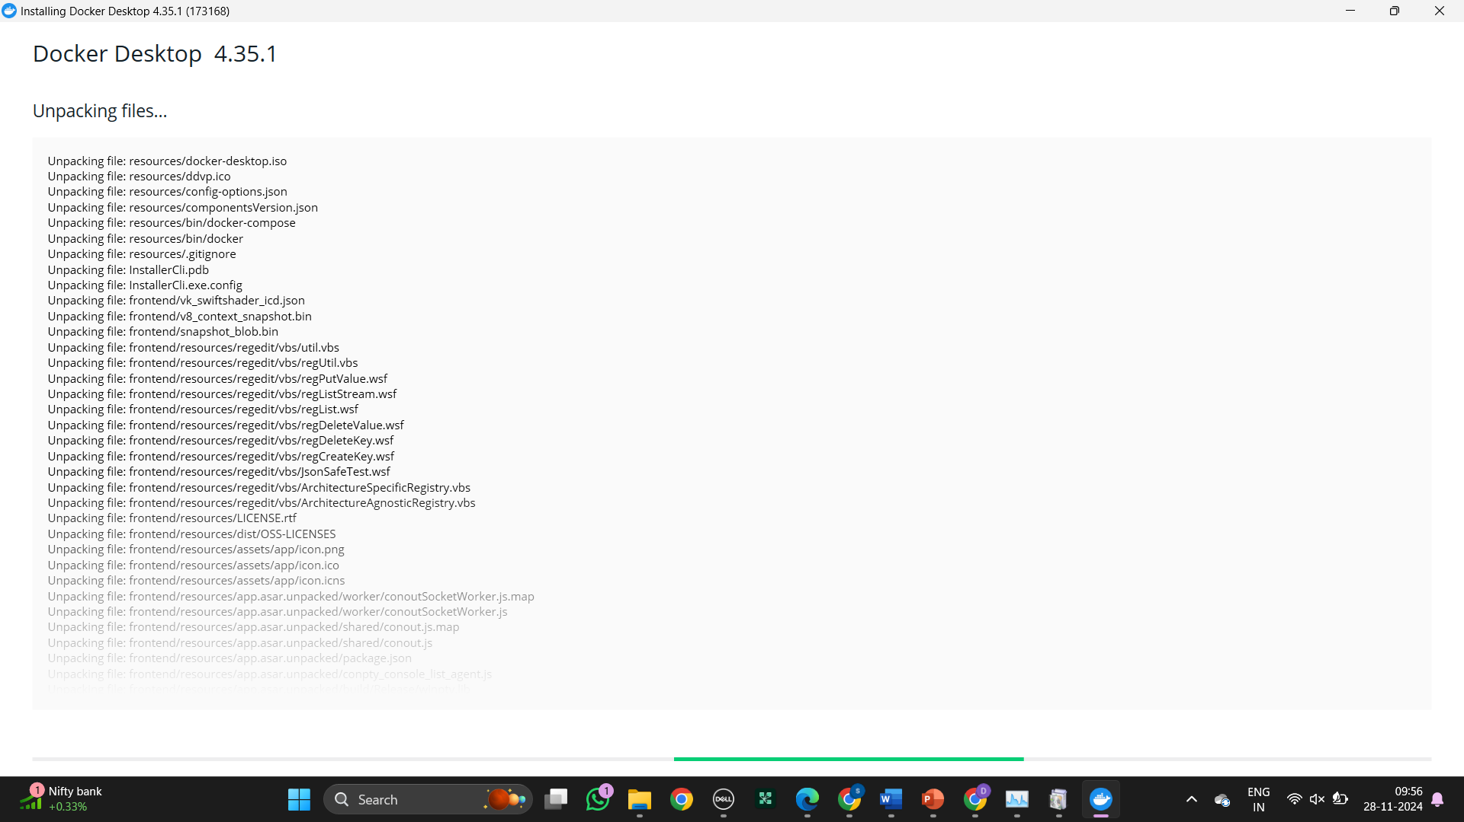

The local Docker Hub is created

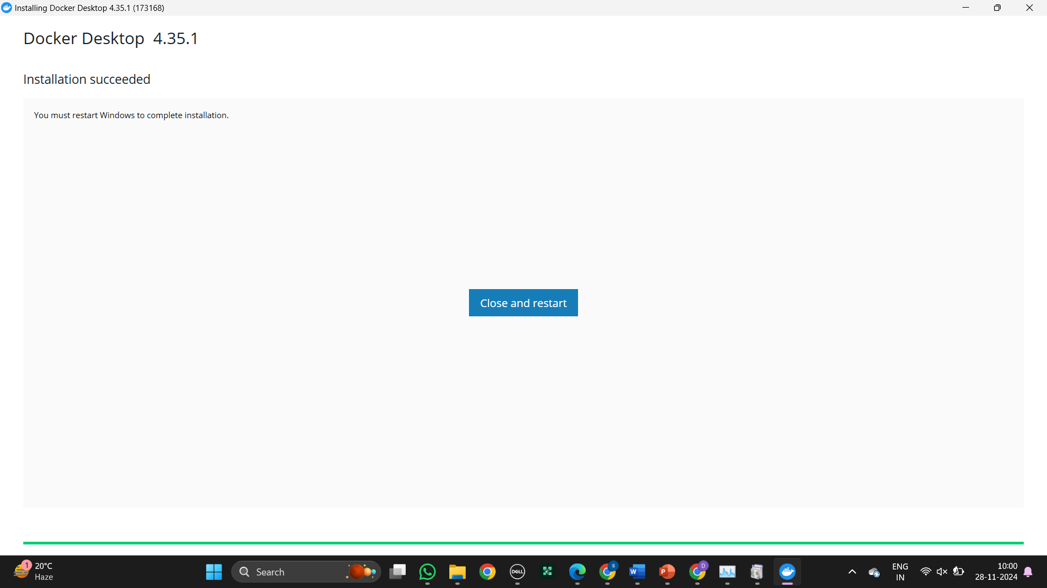

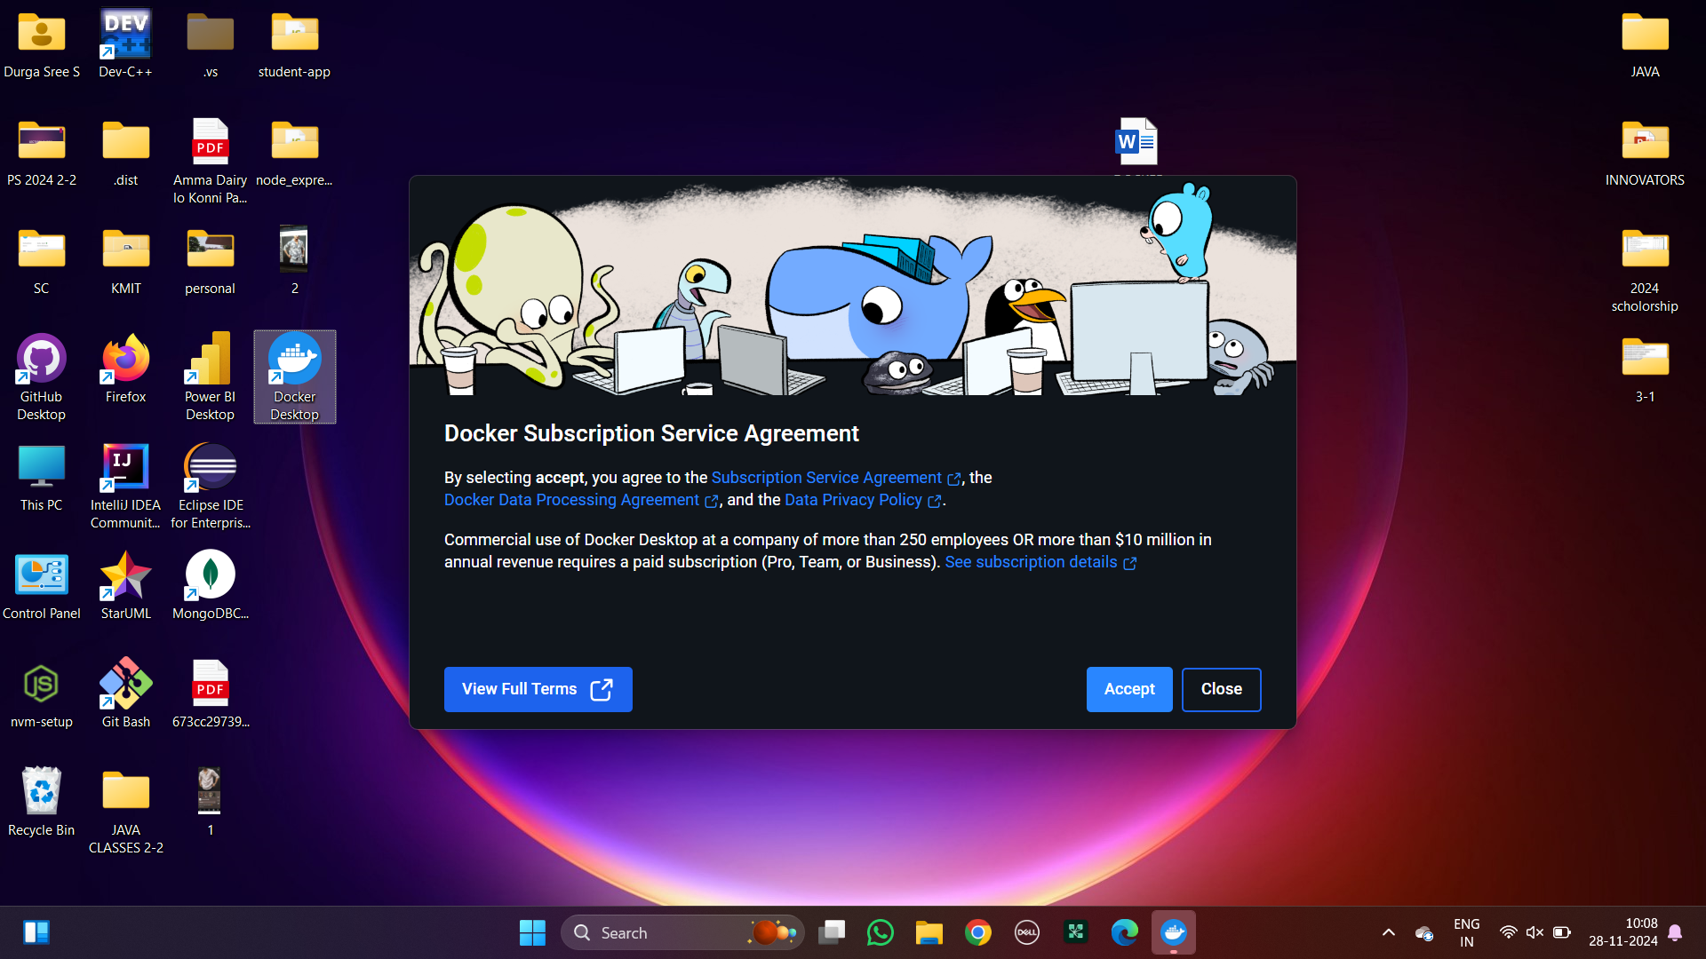

Open Windows PowerShell and enter the command as shown

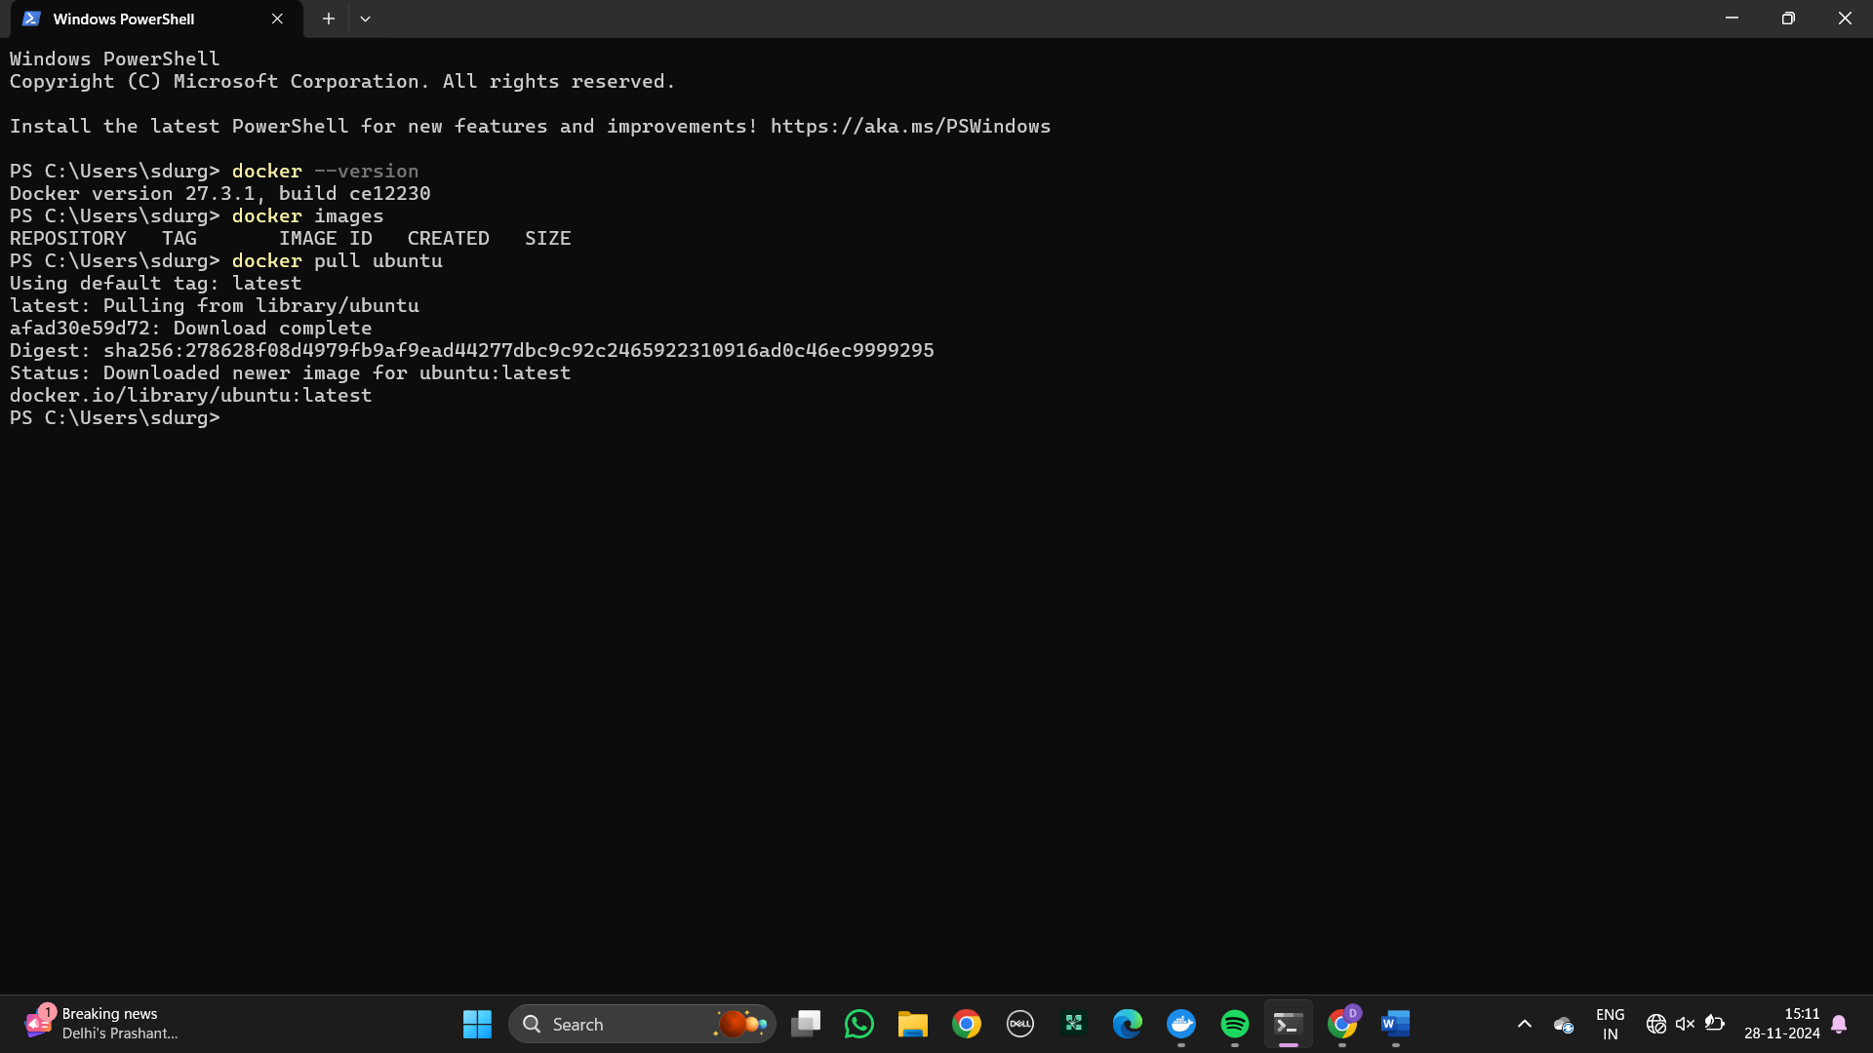

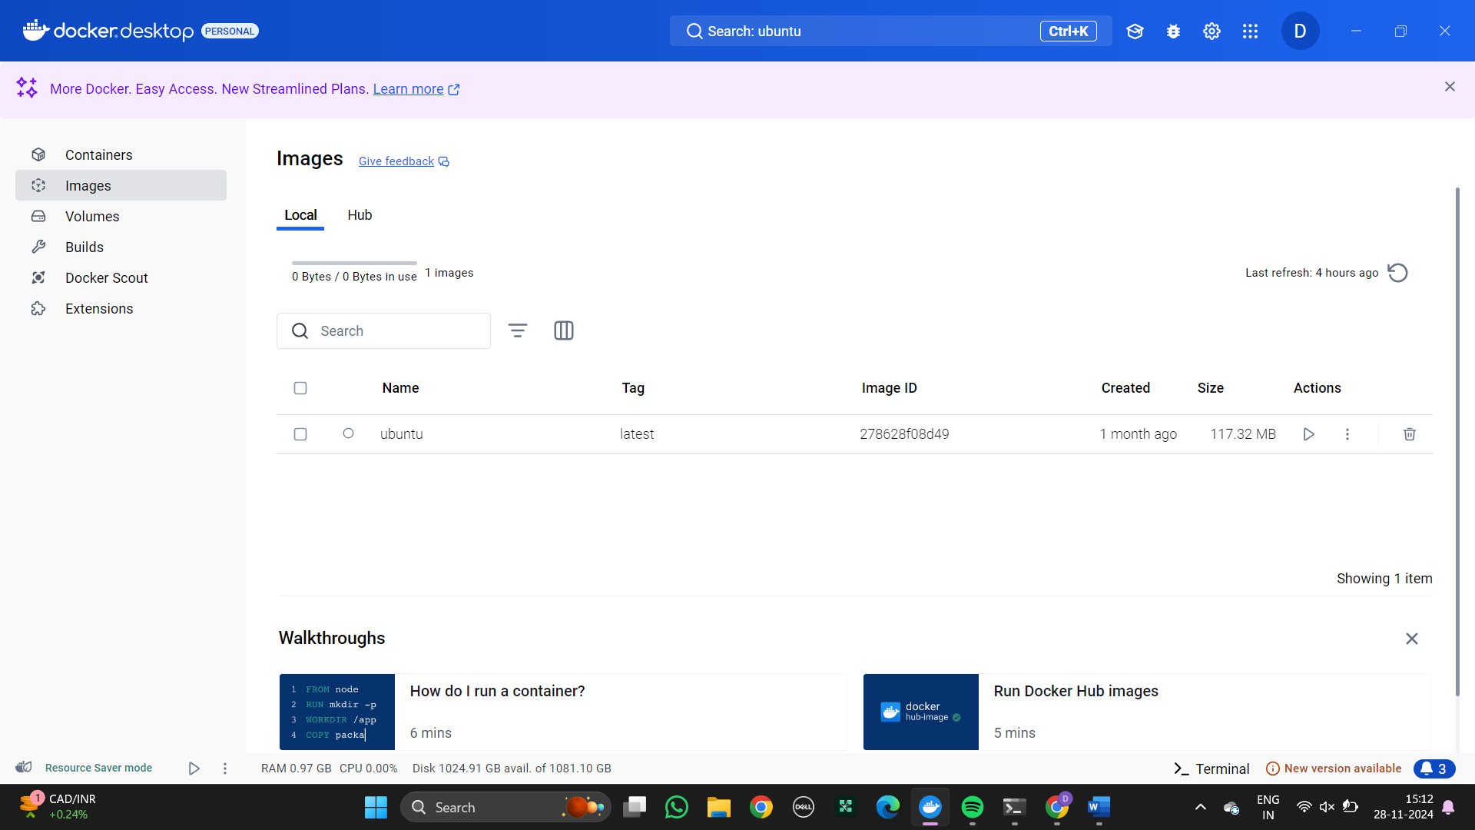

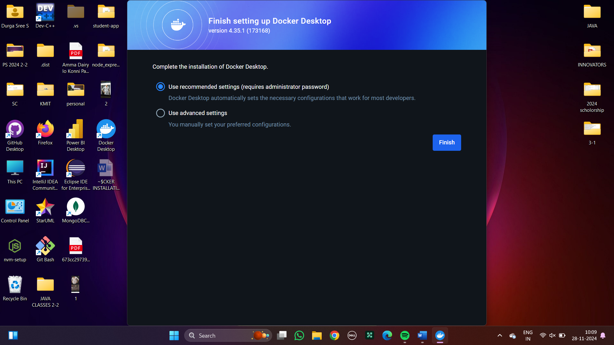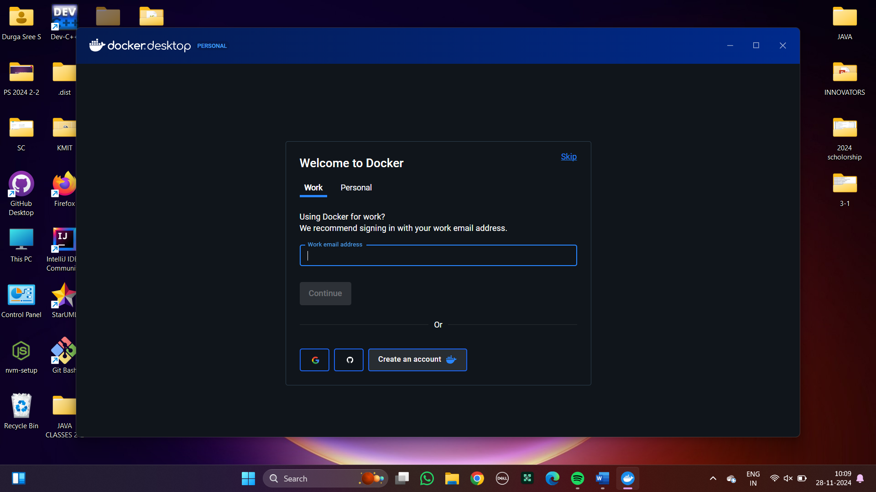

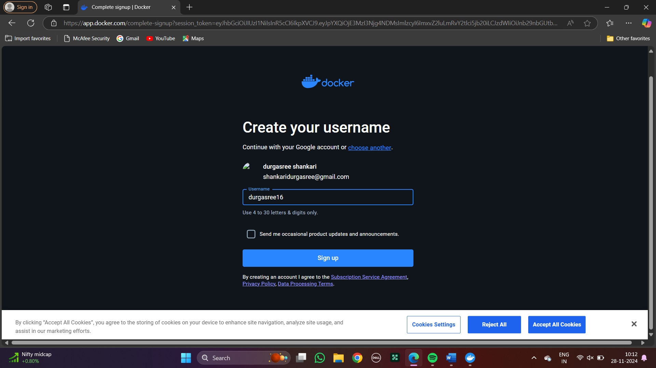

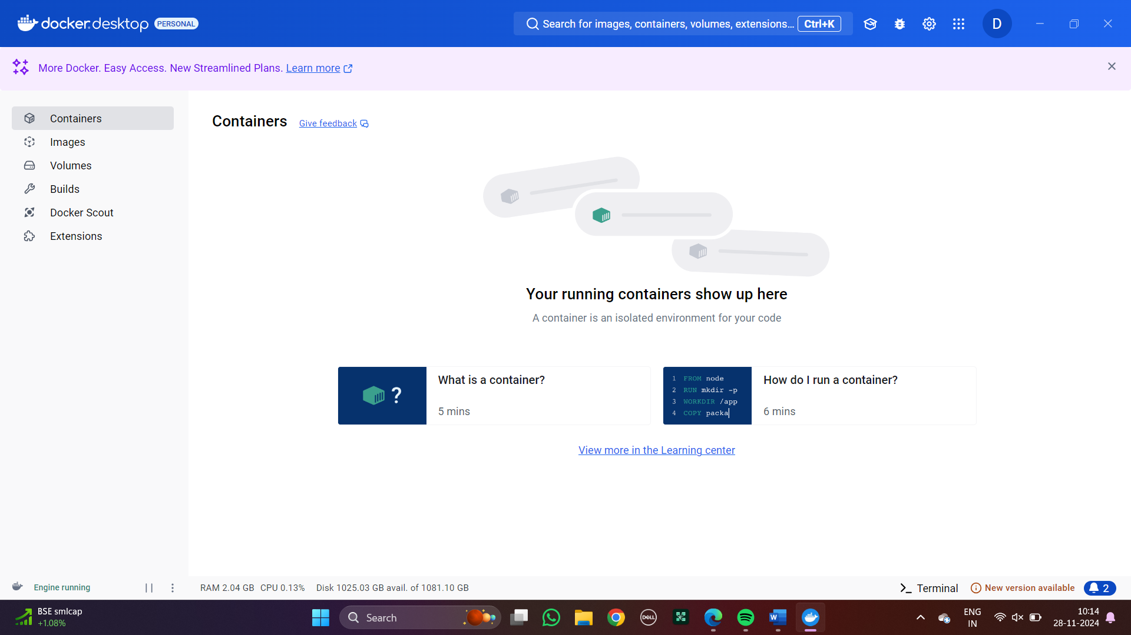

**JENKINS-SCRIPT**

Step 1: Create a new item as jenkins script and opt for pipeline

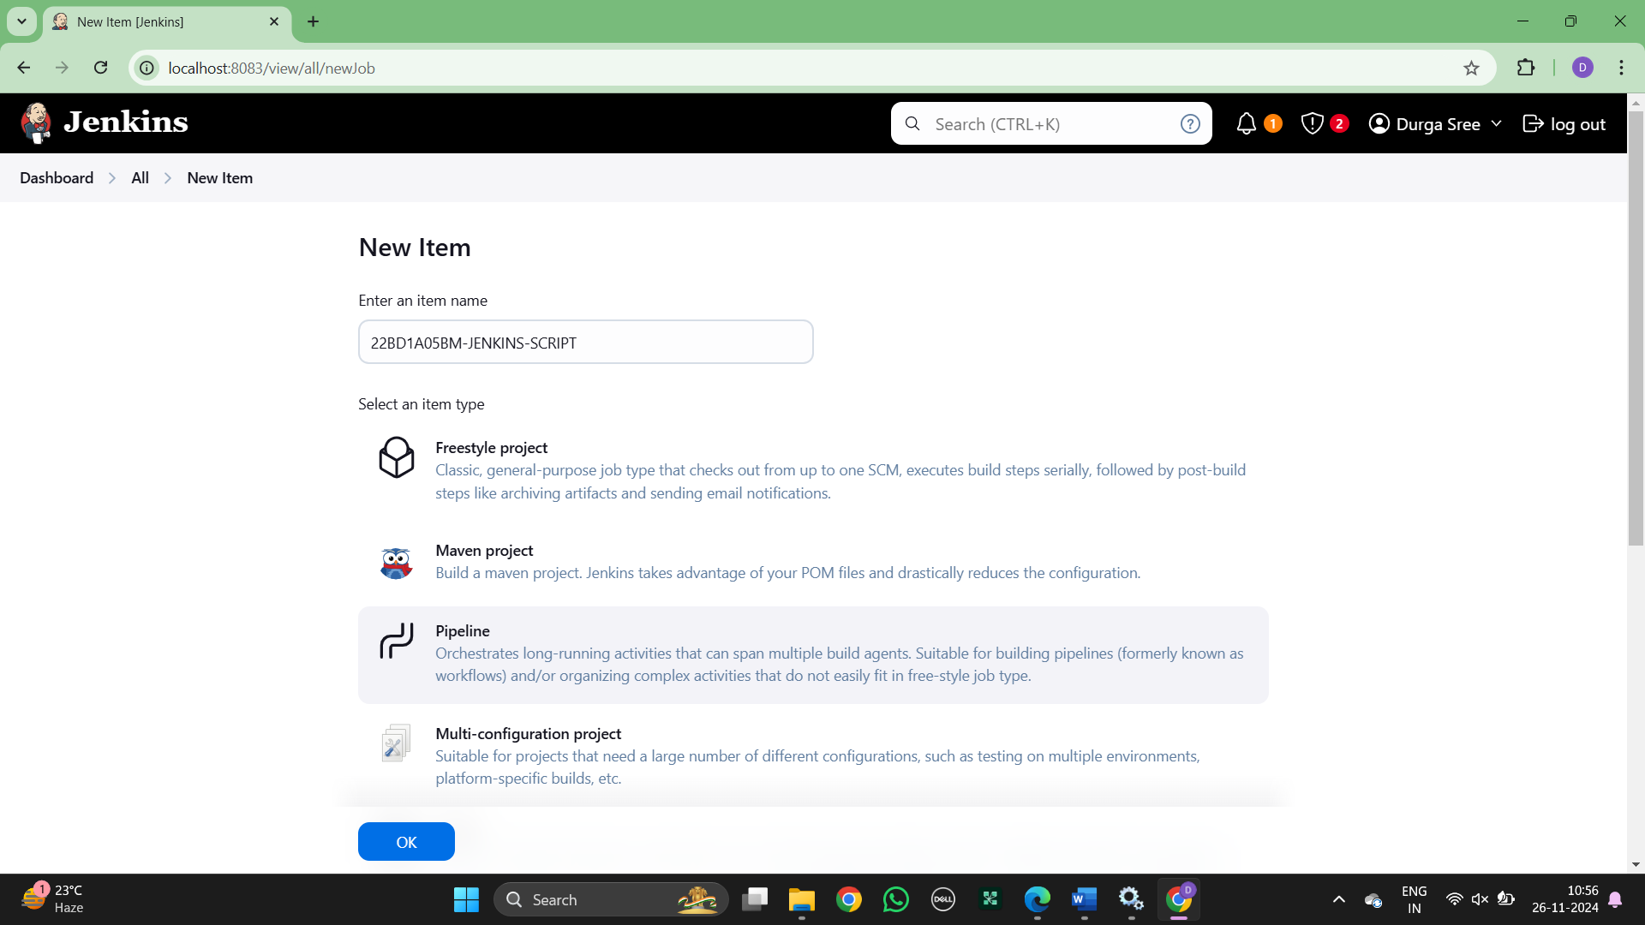

Step 2: Write the Script code with git hub link

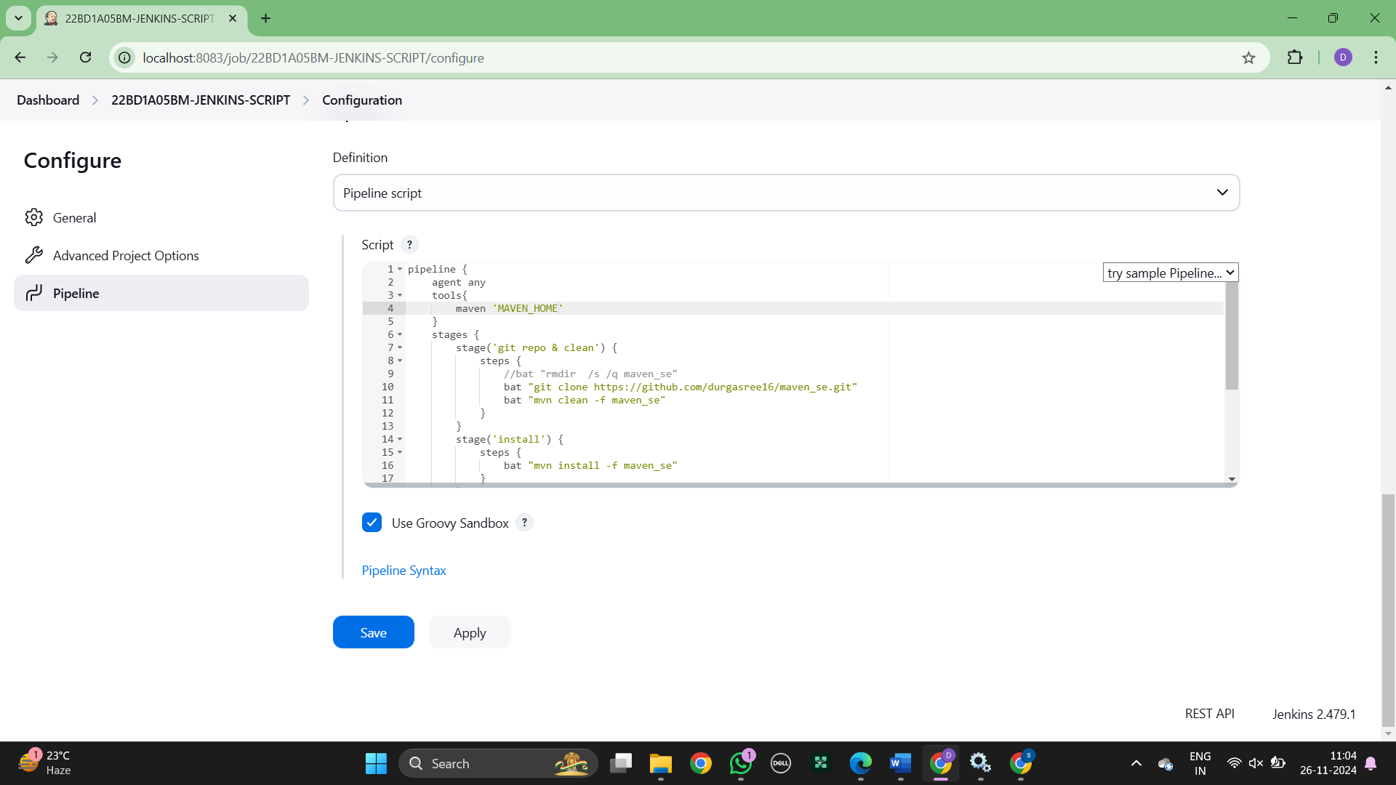

Step 3: Run the script as stages

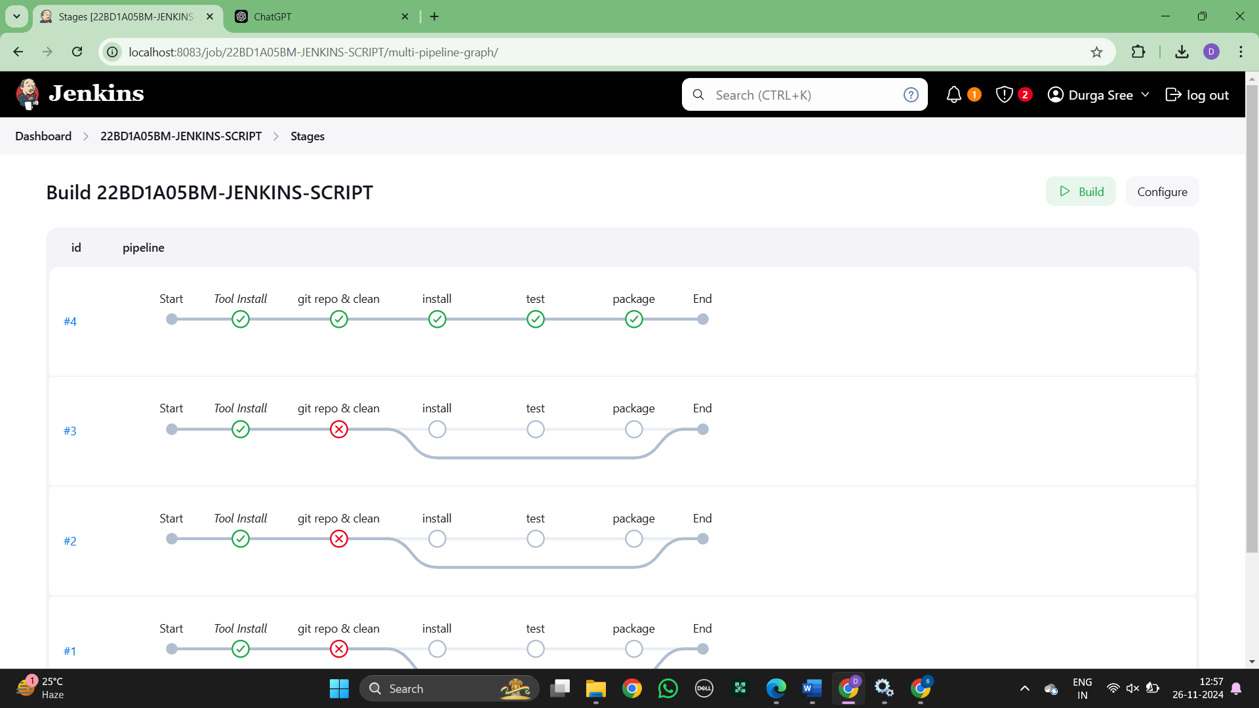

Step 4 : Install the Stage View Pipeline from plugins and the below stages are displayed

